Product Inventory Management System
Project Title 1
Introduction Project Title: Product Inventory Management
Team ID : SWTID-2026-9916
Team Leader:
VANISRI.K & vanisrikumar2312@gmail.com
Team Members:
SWETHA.V& swethavswa@gmail.com
VIJAYAKUMARI.C& chakkrai1156@gmail.com

Abstract
The Product Inventory Management System is designed to help businesses manage and track their products efficiently.
This system allows users to add, update, delete, and monitor product stock in real time. The project reduces manual work, improves accuracy, and ensures better inventory control for small and medium businesses.
Introduction
Inventory management is an important part of any business that deals with physical products.
Traditional manual methods of tracking inventory can lead to errors, loss of products, and inefficient stock management.
This project provides a digital solution to manage product data, track stock levels, and maintain records easily.

Objectives
1. To develop a system that manages product details.
2. To track available stock in real time.
3. To reduce manual inventory errors.
4. To provide an easy interface for users to manage products.

Scope of the Project
The system can be used in small shops, warehouses, and businesses that need a simple way to manage their inventory.
It allows administrators to maintain product details, monitor stock levels, and update product information whenever needed.

Modules
1. User Login Module – Allows authorized users to log in.
2. Product Management Module – Add, edit, and delete products.
3. Stock Management Module – Update product quantity and availability.
4. Report Module – View product lists and stock reports.

System Requirements
Hardware Requirements:
- Computer or Laptop
- Minimum 4 GB RAM
- Internet connection
Software Requirements:
- Operating System: Windows 10 or above
- XAMPP Server
- PHP
- MySQL Database
- Web Browser (Chrome/Edge)

System Architecture
The system follows a client-server architecture.
The user interacts with the web interface using a browser.
The application processes requests through PHP and stores product data in a MySQL database.

Database Design
Table: products
- product_id (Primary Key)
- product_name
- category
- price
- quantity
- supplier

Implementation
The system is implemented using PHP for backend logic, MySQL for database storage,
and HTML/CSS for the user interface. The application runs on a local server using XAMPP.

Mongo db Output
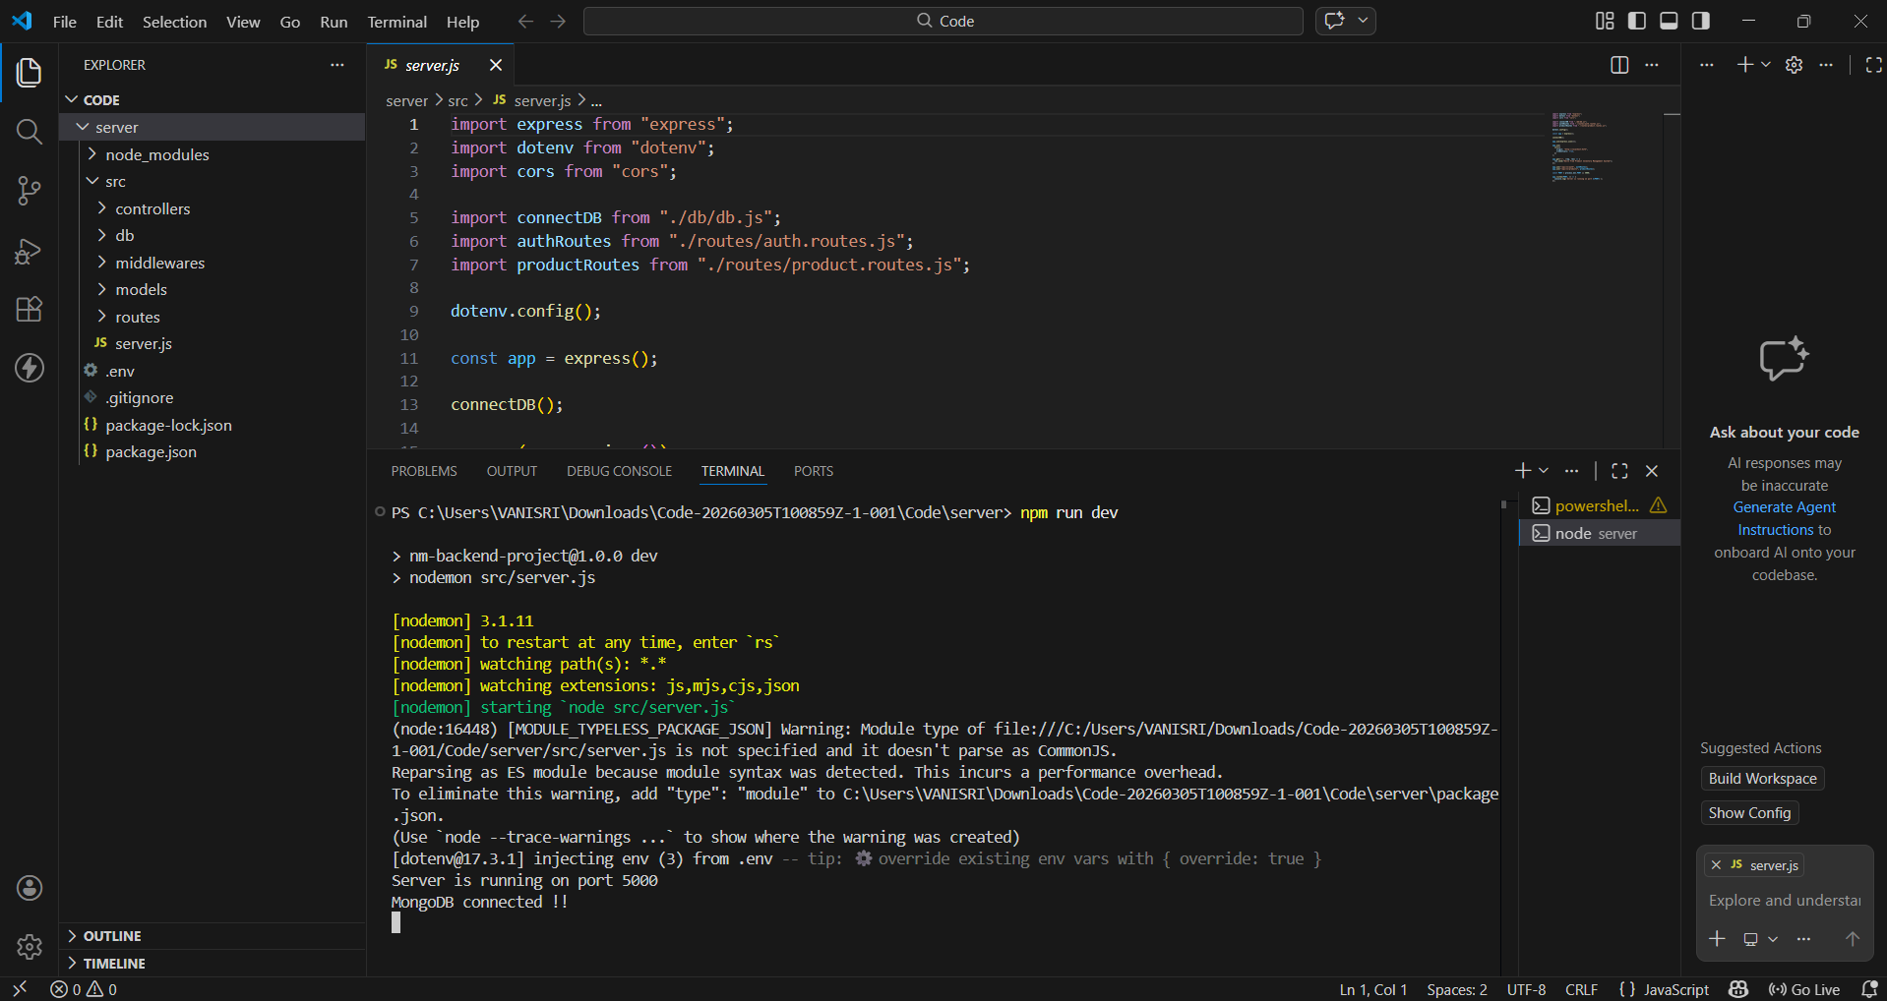

Testing
Testing was performed to ensure that all modules function correctly.
Different test cases were used to verify product addition, deletion, updates, and stock tracking.
User ID Output
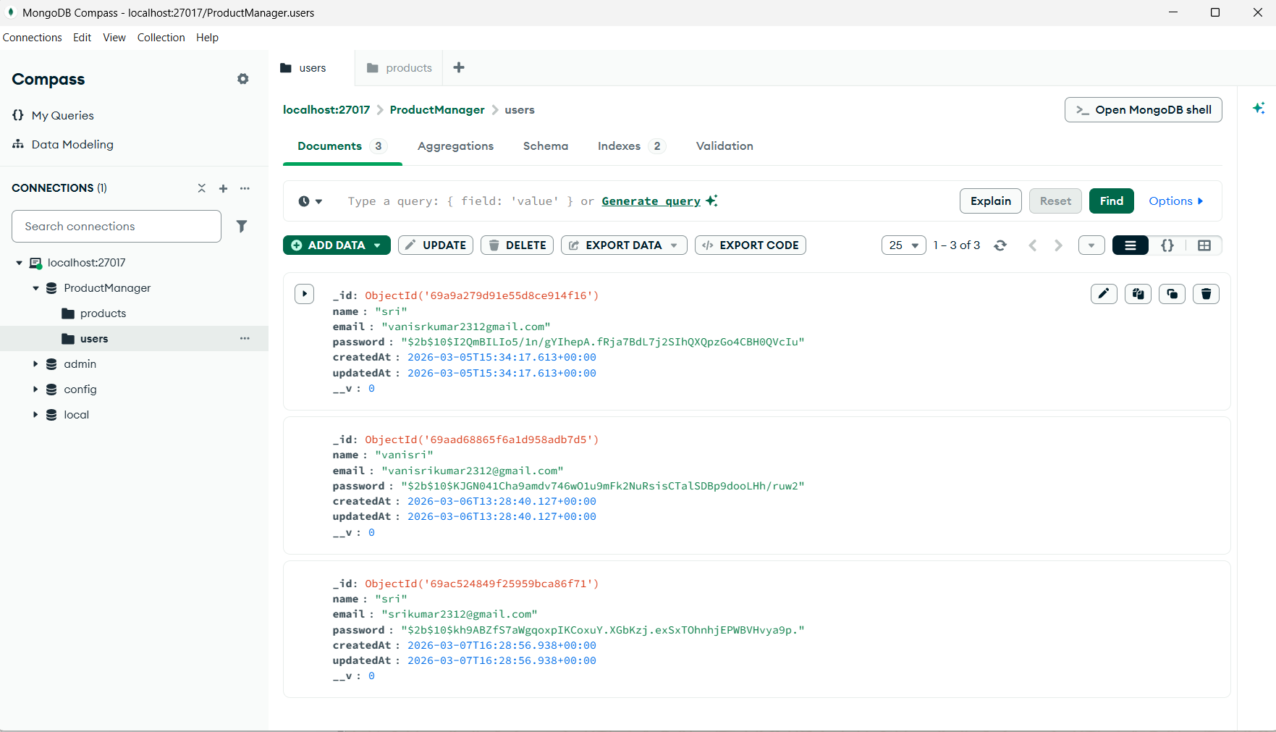

Product Output
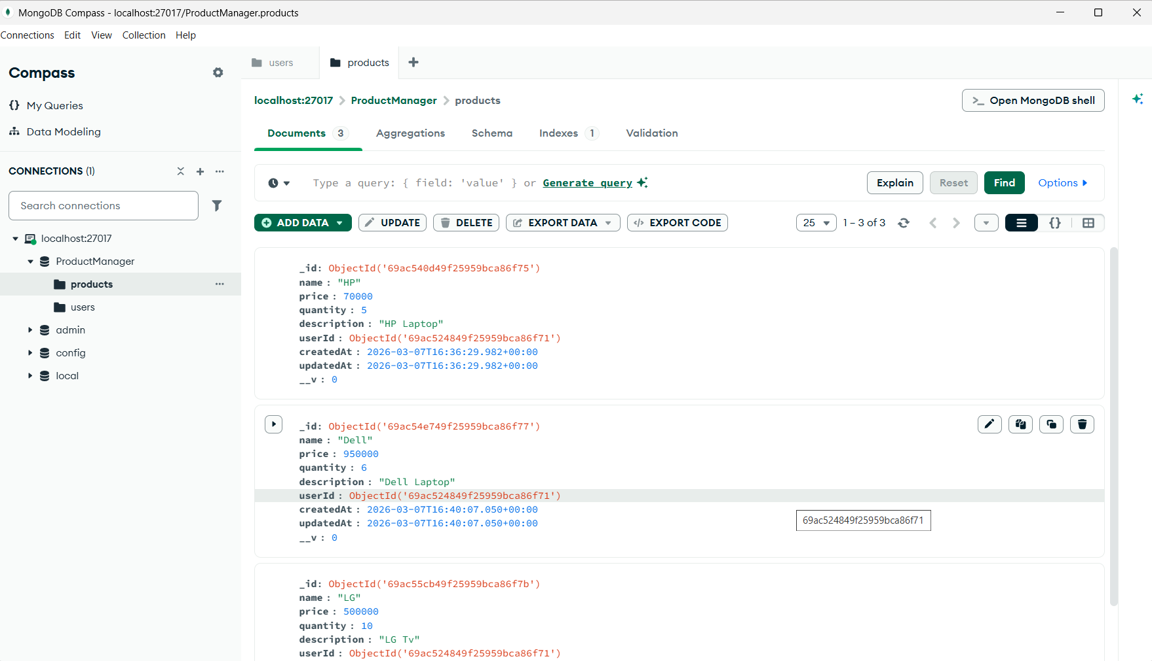

Conclusion
The Product Inventory Management System provides a simple and efficient solution for managing product data and stock levels.
It helps businesses maintain accurate inventory records and improves operational efficiency.

Future Enhancements
- Barcode scanning for products
- Automatic stock alerts
- Mobile application integration
- Advanced sales and purchase reports

